**DOMINICAN COLLEGE OF TARLAC, INC.**

**GymBudd: A Web-based Gym Enthusiast Management System**

A System Analysis and Design Project presented to the

Faculty of the College of Computer Studies,

Dominican College of Tarlac

In Partial Fulfillment of the Requirements

For the Degree of Bachelor of Science in

Information Technology

by:

Developed by:

Alfonso, Andrei P.

Capili, Ryan M.

Santos, Jenny M.

Siron, Maica G.

Rossano C. Samson

Adviser

May 2024

**1.0 Introduction**

**1.1 Project Context**

Nowadays, there are often times when the gym is crowded, and it can be difficult to find available equipment or to work out properly. Also, there’s a time that the other enter in inside the gym are not registered and it can be possible if something is missing or lost inside the gym, it will be difficult to find it because if that day the item is lost, it can be possible for the gym mates to get it. So, if a member ever lose something inside the gym, it will be easier to find it, especially if there is a list and members will know the time and who checked in that day.

Being a gym staff can be difficult work that needs a lot of effort and cost a lot of time. Having to balance their work by assisting their members and maintaining the gym in a safe and clean environment can also be hard in the part of the workers. Their members should be assured that they are in the right gym with the right staff that they have. Having to take care of their members is a heavy responsibility that the workers need to hold accountable.

And there is also the possibility that a list will be lost due to human error, that's why the proponents created a web application to facilitate the search of people registered to do gym in inside the gym. If something is missing or lost inside the gym, it will be difficult to find it because if that day the item was lost, it can be possible for the gym mates to tracked and get it. So, if a member ever lose something inside the gym, it will be easier to find it, especially if there is a list of member, time, and who checked in that day.

Gym staff often experience the challenge of focusing on the attendance of those who go to the gym, especially during busy times and there are classes or programs that must be monitored and record the attendance of members and usually it will be difficult to find if the attendance sheets are only on paper and there's a time where changes of the attendance list accured, such as the addition of a new member, can present a challenge to the staff in recording names. Problems faced by the gym staff when entering members' names, such as double recorning, wrong name entry can interfere with the operation of the gym. It is necessary to check that the visitor is registered to avoid being on two lists at once under the same name.

That is why the proponents came up with a solution to the problems faced by gym members and employees. With Gymbudd's innovative web app, members no longer hesitate to go to the gym because they feel cared for and comfortable in a supportive environment. This system offers affordable prices and is accessible to all fitness enthusiasts. In addition, Gymbudd makes member satisfaction a priority and provides professional staff with a focus to resolve questions quickly. Web applications also simplify the browsing process, removing the hassle of paper-based systems and reducing errors such as double-typing or entering incorrect names. Additionally, Gymbudd's extensive inventory management features provide a record of who has been checked out on a given day, improving security, making it easier to locate lost items, and organizing the environment. Gymbud transforms the gym experience by empowering members and staff to promote a sense of community and trust.

**1.2 Purpose and Description**

The GymBudd web app points to transform exercise centers within the Philippines by presenting innovation that creates administration simpler, quicker, and more effective for exercise center proprietors. GymBudd loosens the forms of exercise center administration, which eases the workload of everybody included. This activity is not as if it were centered on understanding manual challenges, it points to move forward generally operational productivity. What sets this project apart is its commitment to the concerns of exercise center specialists within the Philippines. GymBudd offers a customized arrangement that empowers them to total their errands more proficiently.

**1.3 Objectives**

**1.3.1 General Objectives**

The general objective of the study is to design and develop a system that is focused on fitness administration that aims to provide a simple experience for administrating member gym membership. Features include membership registration, attendance tracking, fitness class management, payment history and more. The emphasis is on simplicity, organization, and reliability to meet the needs of gym managers and members.

**1.3.2 Specific Objectives**

*1.3.2.1* *To develop a time-saving module for gym staff productivity.*

This will automate manual tasks, such as member registration and attendance tracking, to save time for gym staff. By simplifying these processes, the module aims to improve overall productivity and allow staff to focus on providing quality services to gym members.

*1.3.2.2 To create a reform module for well-aimed gym management.*

It will implement automated processes and data validation checks to minimize errors in membership data, attendance data and payment processing. By reducing potential errors, the module aims to ensure detailed and reliability of gym administration.

*1.3.2.3 To design a well-organized class monitoring module for continues operations.*

This will allow gym staff to simply monitor fitness classes, including class attendance, and capacity management. By optimizing class monitoring, the module aims to ensure continues operations and provide an optimal experience for class participants.

*1.3.2.4 To develop an app to adapt and automate different aspects of administrating a gym.*

It uses technology to transform traditional gym processes. It automates tasks such as member management, attendance tracking and payment processing, resulting in better performance and continues gym administration. The goal is to automate different aspects of gym administration, which improves overall operations and member experience.

**1.4 Scope and Limitations**

**1.4.1 Scope**

1.4.1.1 Login

This module allows users to log in.

1.4.1.2 Dashboard

Once logged in, users will be directed to the main module of Gymbudd, where they will have access to all the features of the site.

1.4.1.2.1 Total Registered Members

This module allows the use to view the summary of the total number of members registered in Gymbudd.

1.4.1.2.2 Gender Graph

This module allows the use to view the visual representation, showcasing the distribution of members based on gender.

1.4.1.2.3 Present Members

This module allows the use to view the display number of members who are currently using the platform and engaging in fitness activities.

1.4.1.2.4 Enrolled Class Graph

This module allows the use to view the graphical representation of the number of members enrolled in various Gymbudd classes or programs.

1.4.1.2.5 Total Earnings

This module allows the use to view the information about the financial performance of the platform.

1.4.1.3 Manage Member

Member Management module helps administrators efficiently handle member-related tasks such as adding new members and maintaining an organized list of registered members.

1.4.1.3.1 Add Member

This module allows the administrators to add new members to the Gymbudd.

1.4.1.3.2 Registered Member List

This module allows the use to view the complete list of members registered on the Gymbudd.

1.4.1.4 Attendance

Attendance module helps ensure a smooth and organized gym experience by enabling well-ordered attendance tracking.

1.4.1.4.1 Check-in/Checkout

This module allows the use to record member attendance and track their training sessions.

1.4.1.4.2 Attendance List

This module allows the use to view the overview of member participation over time.

1.4.1.5 Fitness Class

These features in the Fitness Class module help administrators effectively manage and offer a variety of fitness classes within Gymbudd.

1.4.1.5.1 Add Fitness Class

This module allows the administrators to add new exercise classes to the Gymbudd.

1.4.1.5.2 Fitness Class List

This module allows the use to provide a comprehensive list of all fitness classes available on Gymbudd.

1.4.1.6 Payment

This module allows the use to handle member payments and financial records.

**1.4.2 Limitations**

1.4.2.1 Internet Access

Users will need a stable internet connection to access and use the Gymbudd.

1.4.2.2 Cash Payment Recording Only, No Real Money Transactions Supported

The payment module is designed specifically to record payments made in physical cash received by user, rather than processing online money transactions.

**2.0 Review of Related Literature / Systems**

**2.1 Review of Related Theories**

**2.1.1 Visual Studio Code**

Visual Studio Code is a free software used to write and edit code. It is popular among developers because it is easy to use and has many useful features. People like it because it helps them write code faster and with fewer errors. It is also easy to modify, so developers can make it work the way they want.

Author: Microsoft Developer Community

Date Retrieved: March 10, 2024

<https://code.visualstudio.com/>

**2.1.2 JavaScript**

JavaScript is a popular programming language that adds special functions to websites and web apps. It works with the HTML and CSS languages to make web pages interactive. People like to use JavaScript because it is versatile and free. It's used by many websites because it helps them work well and keep them safe from malware.

Author: Brendan Eich

Date Retrieved: March 16, 2024

<https://www.w3schools.com/js/>

**2.1.3 Laragon**

Laragon is an open-source database management system that helps organize and store information. It uses a language called SQL to manage data efficiently. People choose Laragon as their database because it has many useful features, like being reliable and secure.

Author: Leo Khoa

Date Retrieved: March 16, 2024

<https://laragon.org/about/>

**2.2 Review of Related Projects**

**2.2.1 Review of Related Thesis**

**2.2.1.1 “JK Fitness Office: Web based Gym Management System”**

In today's health-conscious society, the demand for gyms has increased as people prioritize their wellness and fitness. This system is specially developed for Jaffna district's JK Fitness centers. The gym is well equipped with modern machines and equipment to provide exceptional service to its clients. As the number of members continued to grow, the gym management realized the need for an IT solution to effectively handle the growing volume.

To develop the system, the project team first gathered user requirements using various techniques to ensure a clear understanding of the scope of the project Based on these requirements, the software was designed and developed using an iterative and incremental approach. The primary objective was to replace the gym's current manual system and provide members with easy access to gym resources while simplifying management processes.

GymBudd finds inspiration from the “JK Fitness Office: Web based Gym Management System”. The system’s effectiveness in optimizing features and improving the user experience is perfectly in line with GymBudd's goals. With its core features such as member management, attendance tracking, payment management, maintenance management, and personalized workout recommendations. The positive reaction and satisfaction of Jaffna district's JK Fitness centers further confirms the importance of the Web based Gym Management System as a source of inspiration for the development of GymBudd.

Author: Nishanthan, M.

Date Published: June 22, 2023

Date Retrieved: March 17, 2024

<https://dl.ucsc.cmb.ac.lk/jspui/handle/123456789/4712>

**2.2.1.2 “Web-Based Management Information System for Services Development: A Literature Review”**

In today's digital era, the development of Internet technologies and applications has created favorable conditions for the establishment of information systems for the management of scientific research. There has been conducted research on the impact of web-based management information systems on service development in organizations and countries around the world. The use of web-based management information systems has emerged as an applicable solution in the current context. To conduct this literature review, an extensive search was conducted using search engines such as Google Scholar and IEEE using specific keywords related to "web-based information management systems for service development".

The findings of this literature review show positive results. and the significant impact of web-based management information systems on service development. Future research in this area will help organizations assess the quality of their web-based services, facilitate design improvements, and ultimately integrate their websites with future services. It is important to note that the scope of this research covers several cases, and the research results are particularly applicable to web-based management information systems for service development.

This literature review generally emphasizes the importance of web-based management information systems in the development of services. The positive effect observed in previous studies is the basis for further research and implementation of these systems in organizations that aim to improve their services and take advantage of the opportunities offered by the digital age.

In conclusion, the "Web-Based Management Information System for Services Development: A Literature Review" highlights the significant impact of web-based management information systems on the development of services. The Web-Based Management Information System for Services Development: A Literature Review results show a positive effect and emphasize the importance of future research for organizations to evaluate and improve the quality of the web-based services. The is a valuable resource for developing GymBudd because it provides insight into the design and implementation of effective web-based management information systems. By combining the principles and recommendations described, GymBudd can improve the quality of its web-based service and facilitate design improvements.

Author: Eny Setyawati and Hasan Hariri

Date Published: March 05, 2021

Date Retrieved: March 17, 2024

<https://doi.org/10.47191/ijcsrr/V4-i3-05>

**2.2.2 Review of Related Systems**

**2.2.2.1 “Wodify”**

Wodify a gym and studio management software designed to help business owners efficiently manage their operations. With features like performance tracking, automated billing, client management and more, Wodify simplifies processes and enhances management capabilities. The researchers have chosen this system as their inspiration due to its features and design. It would be used as the basis for the dashboard, client management and more.

Insights of client’s module contain reporting and insights from class attendance to financials, quickly access the reports of the members.

Client management module that contains the client information where they can track attendance, enforce membership guidelines, and send digital waivers. The invoices module lets the user check client payments with the option to filter and search for a member.

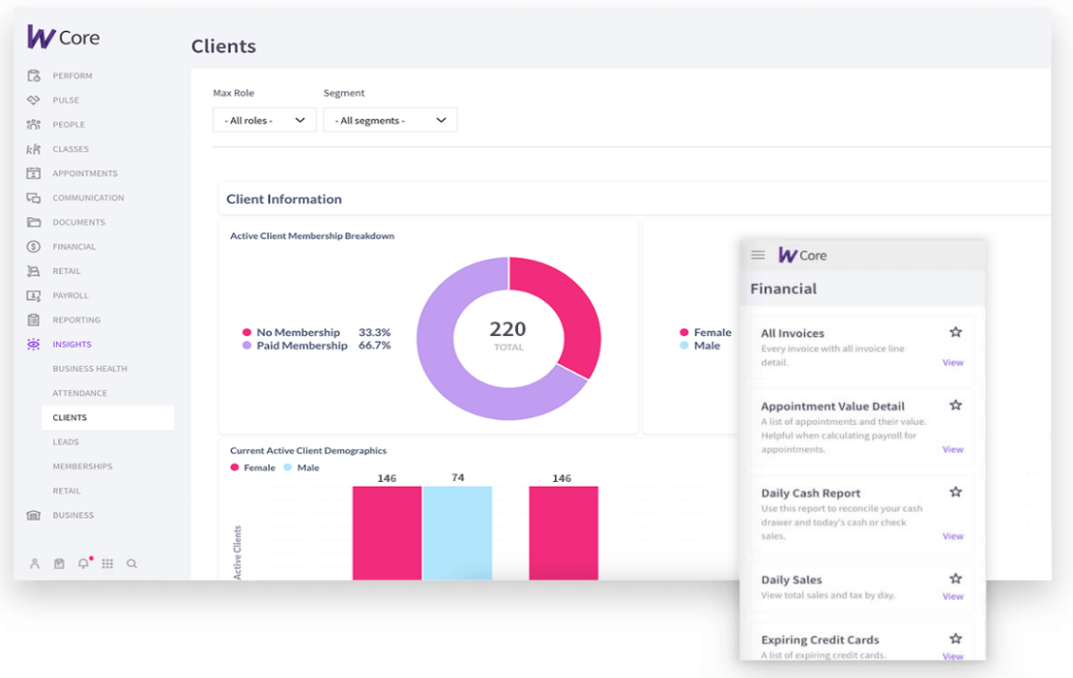

Figure 1: Screen of Clients Module

Figure 2: Client Management Module

Figure 3: Invoices Module

Developed by: Wodify Technologies

Date Published: March 2020

<https://www.wodify.com/products/core/features>

**2.2.2.2 “JK Fitness Office”**

JK Fitness Office is a web-based application developed to help JK fitness with managing all aspects of their business, engaging with members more effectively and growing the business further. The researchers have chosen this system as their inspiration due to its straight-forward design and features. It would be used as the basis for the proper format of forms details.

The employee module shows a form for the application of a new member.

The membership module shows all the members, with the option to view the information of the member, edit, and delete a member. The members information form shows detailed information of the member.

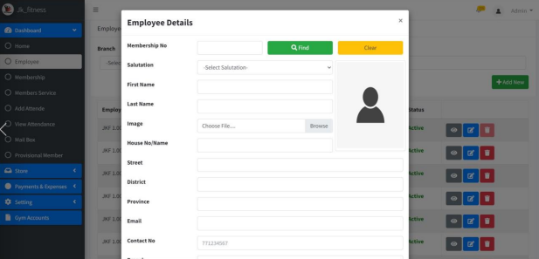

Figure 1: Employee Module

Figure 2: Membership Module

Figure 3: Members Information Form

Developer: Nishanthan, M.

Date Published: June 22, 2023

<https://dl.ucsc.cmb.ac.lk/jspui/handle/123456789/4712>

**3.0 Technical Background**

**3.1 Development**

**3.1.1 Hardware**

3.1.1.1 Laptop and Computer

The main devices that will be used by the proponents to develop this system will be personal computers (PCs), desktop computers, and laptops. The choice of software will depend on availability and personal preference. However, it will be important to consider factors such as storage capacity, memory, processing power, compatibility, and efficiency of the device. These considerations will ensure the smooth development of the system and the seamless integration of required systems or access to real websites. For the development process to be effective, it will be crucial to have access to a working laptop or desktop computer.

**3.1.2 Software**

3.1.2.1 Visual Studio Code

Visual Studio Code will be used as the code editor for development operations such as debugging, task running, and version control. It will provide the necessary tools for a quick code-build-debug cycle, while more complex workflows will be handled by fuller featured IDEs like Visual Studio IDE.

3.1.2.2 Figma

Figma will be used by the proponents, particularly the UI/UX designers and graphic designers, to create, share, and test designs in high fidelity prototypes for the system. It will serve as a collaborative platform, allowing the proponents to be involved in the design process to contribute, provide feedback, and make informed decisions.

3.1.2.3 Laragon

Laragon will be used as the database for storing and managing data, ensuring efficient data storage and retrieval. Laragon's fast and lightweight features, along with its ease of use and extensibility, will make it the ideal choice for building and managing modern web applications. The latest release of Laragon as of April 2024 will be used, ensuring compatibility and access to the latest features and enhancements.

3.1.2.4 HTML

Hypertext Markup Language will play a crucial role in organizing the content of the web application. It serves as the standard language for creating web pages, defining how content is structured on the web.

3.1.2.5 Javascript

JavaScript will be used in the system to make it more interactive and functional. This programming language allows for dynamic content updates, form validation, and interactive features on the web pages. By incorporating JavaScript, the system will become more engaging and responsive to user actions. It will help create a dynamic and interactive user experience within the web application.

**3.1.3 Peopleware**

3.1.3.1 The Proponents

The proponents will have their own designated tasks that need to be accomplished for the project to be completed. The proponents will consist of a programmer who will be responsible for coding and designing, a project manager who will be responsible for managing the team, and two co-programmers who will be assigned to assist the programmer. Each member of the team will contribute their skills and expertise to ensure the successful completion of the project.

3.1.3.2 System Analysis and Design (SAD) Adviser

Mr. Rossano C. Samson, L.P.T., will provide invaluable expertise and guidance in selecting the best project for the proponents to develop. He has offered advice, suggestions, and guidance throughout the creation of the document, providing necessary revisions. Mr. Samson will ensure that the document is of high quality and follows the appropriate format that will be developed by the proponents.

**3.2 Implementation**

**3.2.1 Hardware**

3.2.1.1 Computer or Laptop

The user will require a personal computer or laptop to use the system because the system is developed as a web application. Web applications are designed to be accessed through web browsers, and personal computers or laptops provide the necessary hardware and software capabilities to run web browsers effectively. The minimum hardware requirements will be 4 GB RAM and 2 GB available space. The latest and recommended hardware requirements include 8 GB RAM and 4 GB available space. The minimum system requirement will be Windows 8, while the recommended system requirement is Windows 11.

**3.2.2 Software**

3.2.2.1 Web Browser

The user will require a web browser to access and use the system. As a web application, the system is designed to be accessed through web browsers. The supported web browsers include Google Chrome, Mozilla Firefox, Microsoft Edge, and Safari. The minimum version of the web browser required is Chrome 75, Firefox 68, Edge 18, or Safari 12. For optimal performance, it is recommended to use the latest versions of these browsers.

**3.2.3 Peopleware**

3.2.3.1 Fitness Centers/Gyms Owners

Fitness centers and gyms owners can use Gymbudd to improve their services and connect with their members. It will help them with managing their operations and providing a better experience for their members.

**4.0 Methodology**

**4.1 Methodology**

The Rapid Application Development (RAD) model is an iterative and incremental software development approach that emphasizes rapid prototyping, close collaboration between developers and users, and quick delivery of functional software. The RAD model is well-suited for Gymbudd due to its specific requirements and constraints.

By following the RAD model, Gymbudd can benefit from rapid prototyping, close collaboration, and quick delivery of a functional fitness application. The phased approach ensures that all aspects of the application, from requirements planning to user design and construction, are carefully considered, and executed. The RAD model's emphasis on flexibility and quick iterations will enable Gymbudd to meet the evolving needs of gym staff and members, providing a highly usable and effective fitness solution.

Figure 1: Rapid Application Development Model

The following are the phases of RAD Model:

4.1.1 Requirements Planning

In the first phase, the proponents will work closely to decide on the functions and key features that the Gymbudd application should include. The emphasis will be on understanding the core requirements and priorities of the project.

4.1.2 User Design

In the second phase, the non-technical design aspects of the Gymbudd system will be discussed. This includes the user interface design, user experience considerations, and any other design elements that will enhance the usability and appeal of the application.

4.1.3 Construction

In the third phase, the designs created in the previous phase will be further enhanced and developed. The proponents will focus on building the functionality of Gymbudd, ensuring that it aligns with the requirements and design specifications. Rapid prototyping will be utilized to quickly produce functional prototypes that can be tested and validated by users.

4.1.4 Cutover

In the final phase, the old application (if any) will be replaced with the new Gymbudd application. The transition from the old system to the new one will be carefully planned and executed to minimize disruption and ensure a smooth transition for gym staff and members.

**5.0 Conclusion and Recommendation**

**5.1 Conclusion**

In the Requirements Planning phase, we learned that it's crucial to work closely together and understand the main needs and priorities of the Gymbudd application. This helped us decide on the key functions and features that the application should have, making sure it meets the needs of gym staff and members.

During the User Design phase, we realized the importance of designing the application in a way that is easy for users to understand and use. We focused on creating a user-friendly interface and considering how users will interact with the application. This made sure that the application was visually appealing and easy to navigate.

In the Construction phase, we learned the value of building the application in small steps and getting feedback from users along the way. We created prototypes quickly and tested them to see if they worked well for users. This allowed us to make improvements and create a better application based on user feedback.

Overall, the methodology used in Chapter 4 taught us the importance of working together, understanding user needs, and continuously improving the application. These lessons will help us create a fitness solution for Gymbudd that is easy to use and meets the changing needs of gym staff and members.

**5.2 Recommendation**

For future researchers and developers working on gym management systems like GymBudd, the proponents suggest that incorporate an inventory management feature to easily track the availability of equipment and supplies in the gym. This will help gym owners ensure they always have enough resources to meet the needs of their members.

They recommend ensuring the compatibility with various platforms, including mobile devices, to provide convenience and accessibility to both gym staff and members. This will allow users to access GymBudd on the go, making it easier for them to manage their gym activities from anywhere.

Also, provide customization options to allow gym owners to tailor the system to their specific needs and preferences. This will enable them to personalize the application according to their unique requirements and be effective in managing their gym operations.

Additionally, it is suggested that future researchers include a feature in their gym management systems to support online money transactions. This would allow users to conveniently make electronic payments, offering them more choices for payment and accommodating different user preferences.